Load Average

**System load/CPU Load-:**

* is a measurement of CPU over or under-utilization in a Linux system
* the number of processes which are being executed by the CPU or in waiting state.

**Load average-:**

* is the average system load calculated over a given period of time of 1, 5 and 15 minutes.
* the load-average is technically believed to be a running average of processes in it’s (kernel) execution queue tagged as running or uninterruptible.
* A downright idle Linux system may have a load average of zero, excluding the idle process.
* Nearly all Unix-like systems count only processes in the running or waiting states. But this is not the case with Linux, it includes processes in uninterruptible sleep states; those waiting for other system resources like disk I/O etc.

**There are numerous ways of monitoring system load average including uptime which shows how long the system has been running, number of users together with load averages:**

* **Uptime**



The number are read from left to right and the output means below that

load average over the last **1** minute is **0.28**

**load average over the last 5 minutes is 0.12**

**load average over the last 15 minutes is the 0.05**

**A high load averages imply that a system is overloaded ;many process are waiting for CPU time.**

* **top -:** display a real-time state of a running Linux system, plus many other tools

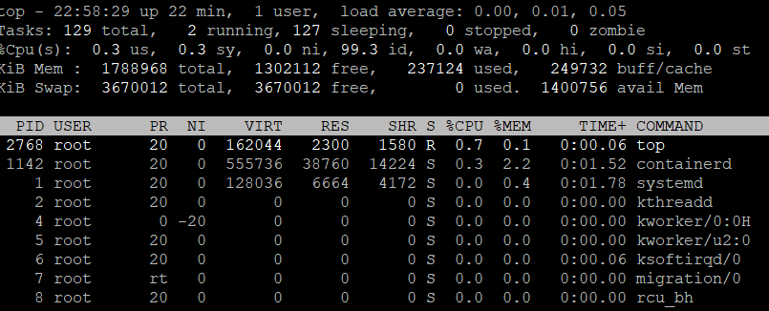

* **glances -:** display a real-time state of a running Linux system, plus many other tools

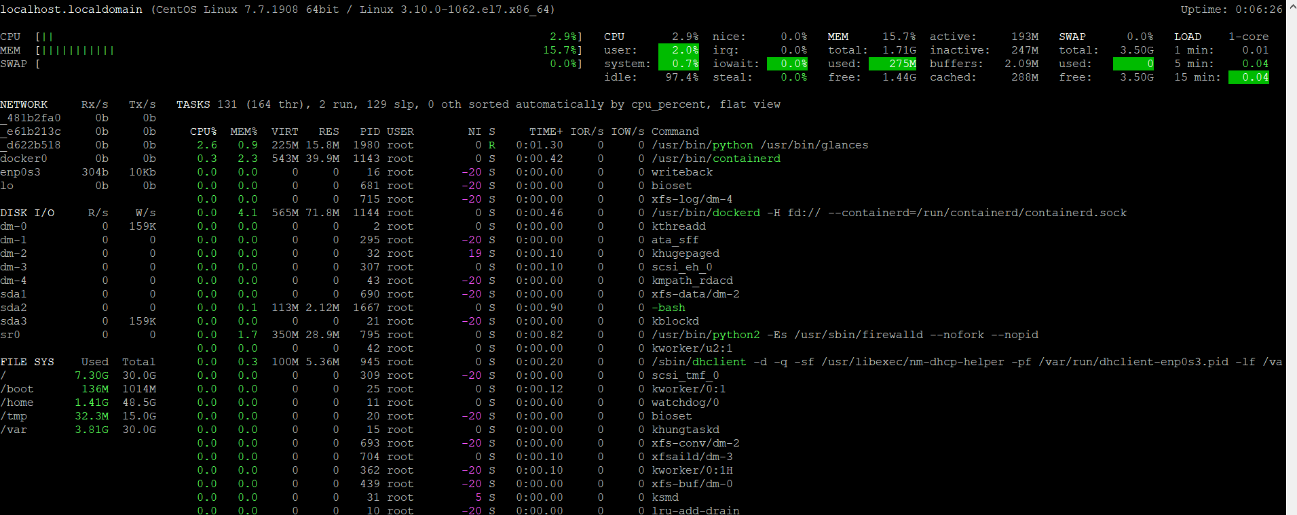

The load averages shown by these tools is read **/proc/loadavg** file, which you can view using the [cat command](https://www.tecmint.com/13-basic-cat-command-examples-in-linux/) as below:

* cat /proc/loadavg



**Multi-processor Vs Multi-core**

* **Multi-Processor -:** in this two or more cpu’s are integrated into a single computer system
* **Multi-**core Processor-: I single physical cpu which has at least two or more separate cores that work in parallel

Meaning a dual-core has 2 two processing units, a quad-core has 4 processing units and so on.

Note that a single CPU core can only carry out one task at a time, thus technologies such as multiple CPUs/processors, multi-core CPUs and hyper-threading were brought to life.

With more than one CPU, several programs can be executed simultaneously. Present-day Intel CPUs use a combination of both multiple cores and hyper-threading technology.

To find the number of processing units available on a system, we may use the [nproc or lscpu commands](https://www.tecmint.com/check-linux-cpu-information/) as follows:

* Nproc
* Lscpu

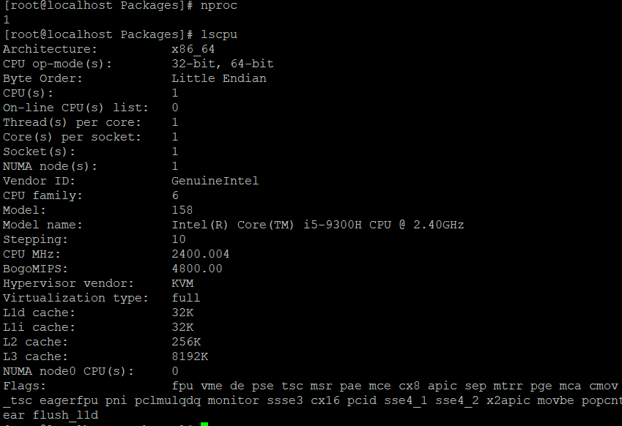

Another way to find the number of processing units using [grep command](https://www.tecmint.com/12-practical-examples-of-linux-grep-command/) as shown.

* **grep 'model name' /proc/cpuinfo | wc -l**

